Database System Lab

Project: Chat System

Submitted To: Ma’am Saira Shaheen
______________________________________________________________________________________________________________________________________________________________________________________________________________________________________
Student Name: Aman Siddiqui
_______________________________________________________________________________________________________________________________________________________________________________________________________________________________________
Reg Number: 2280104
_______________________________________________________________________________________________________________________________________________________________________________________________________________________________________
Section: BSSE 4A
____________________________________________________________________________________________________________________________________________________________________ ___________________________________________________________________

Introduction:
The purpose of the chat system is to facilitate communication and interaction between users through text, multimedia messages, and group chats. The system allows users to exchange messages, create and participate in group chats, send attachments (such as images, videos, and files), and receive notifications about various events, such as new messages, calls, or group invitations.
Database Design and Implementation:

- Establishing Tables and Adding Data: We'll create database tables to store information of chat system and insert sample data using SQL commands.

- Enforcing Attribute Constraints: We'll use constraints like Unique, NOT NULL, NULL and DEFAULT to ensure data integrity and validity.

- Implementing Key and Referential Integrity: Primary and Foreign Key constraints are used to maintain data consistency and define relationships between tables.

- Attribute Constraints:
- NOT NULL: Ensures that a column cannot have a NULL value.
- NULL: NULL is useful when you want to indicate that the value for a particular column is unknown or not applicable.
- UNIQUE: UNIQUE is applied to prevent duplicate entries in a column, which is important for fields that must have unique values.

- Primary Key:
- Primary key always has unique data
- A primary key cannot have null value.
- A table can contain only one primary key constraint

- Foreign Key:
- FOREIGN KEY is a key used to link two tables together.
- A FOREIGN key in one table used to point PRIMARY key in another table.

- INSERT INTO: Add new rows of data into a specified table in a database.

- UPDATE: Modify existing rows of data in a specified table based on certain conditions.

- ALTER: Modify the structure of an existing database table, such as adding, deleting, or modifying columns.

- JOINS:
- INNER JOIN: It retrieves records that have matching values in both tables involved in the join.
- LEFT JOIN: It returns all records from the left table and the matched records from the right table.
- RIGHT JOIN: It returns all records from the right table and the matched records from the left table.
- CROSS JOIN: It returns the Cartesian product of the two tables, meaning it combines each row from the first table with every row from the second table, resulting in all possible combinations.

- DISTINCT: Removes duplicate records from the result set, returning only unique values.

- LIKE Operator: Used to search for a specified pattern in a column.

- NOT LIKE Operator: Used to exclude rows that match a specified pattern.

- IN Operator: Find rows where a column's value matches any value in a list.

- BETWEEN Operator: Used to find rows with values within a specific range.

- NOT BETWEEN Operator: Used to find rows with values outside a specific range.

- Logical Operators (AND, OR): Combining conditions in queries.

- ORDER BY: Sort the results by one or more columns.

- Sub-Queries: Enclosed within parentheses, used within another query for filtering, joining, or calculations.

- EXISTS Function: Shows existence of rows returned by a subquery.

- Aggregate Functions:

- COUNT(*): Returns the total number of rows in a table, including rows with NULL values.
- SUM: Calculates the total sum of a numeric column.
- AVG: Returns the average value of a numeric column.
- MIN: Finds the smallest value in a column.
- MAX: Finds the largest value in a column.

- GROUP BY Clause: The GROUP BY clause is used in conjunction with the SELECT statement and Aggregate functions to group rows together by common column values.

- HAVING Clause: Filters grouped rows based on specified conditions after grouping and aggregate calculations.
Conclusion:

In conclusion, the chat system provides a comprehensive platform for seamless communication and interaction among users. With features like text and multimedia messaging, group chat creation, and attachment sharing, it promotes effective collaboration and connectivity. Moreover, real-time notifications ensure users stay updated on important events, enhancing their overall experience. Overall, the project aims to foster efficient and engaging communication while catering to diverse user needs in a modern digital environment.

INSERT

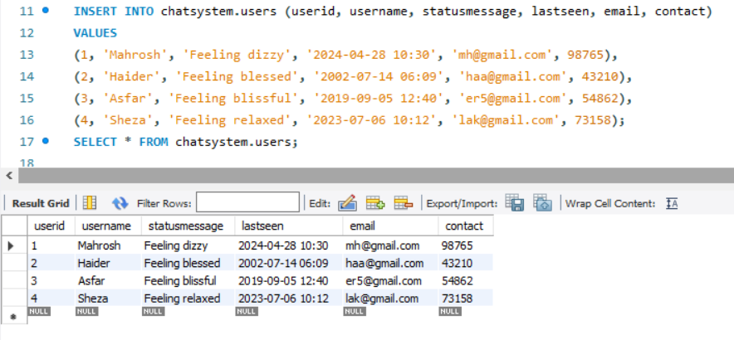

UPDATE

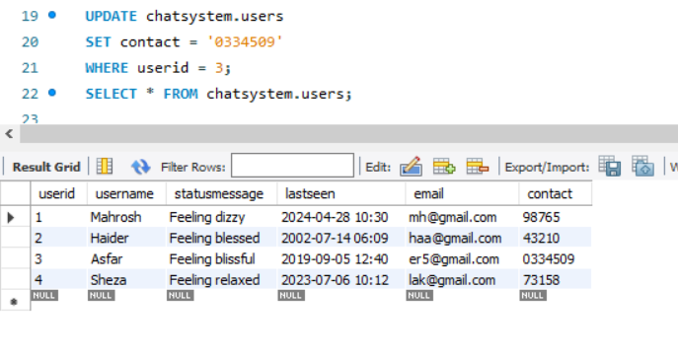

ALTER

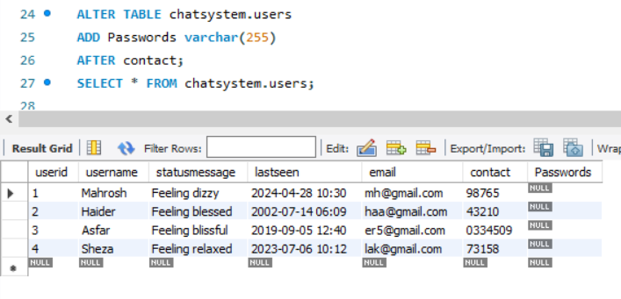

DISTINCT
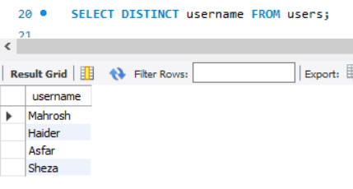

INNER JOIN
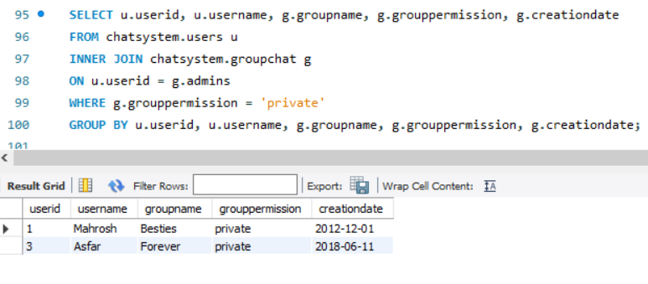

LEFT JOIN
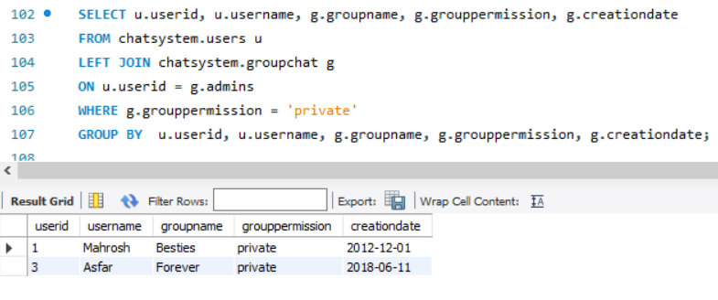

RIGHT JOIN
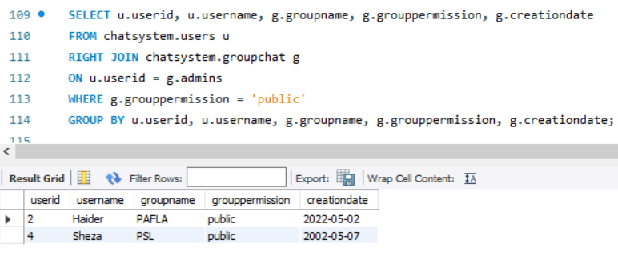

CROSS JOIN

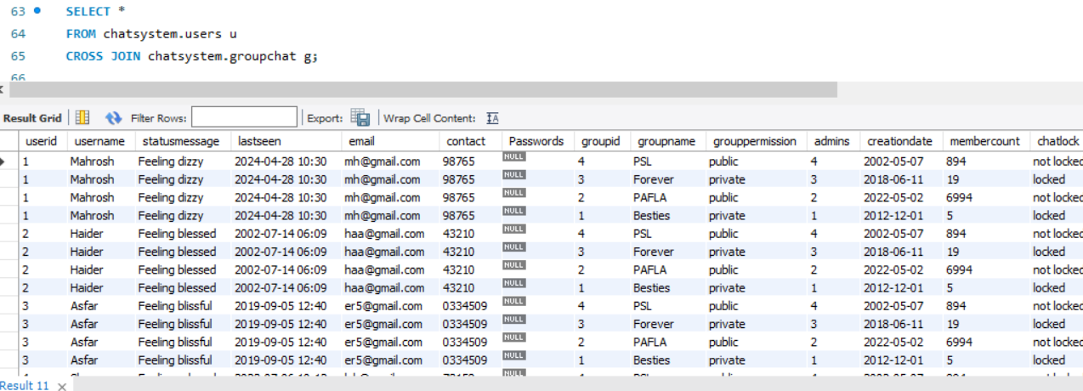

LIKE OPERATOR

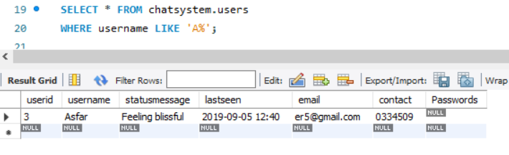

NOT LIKE OPERATOR

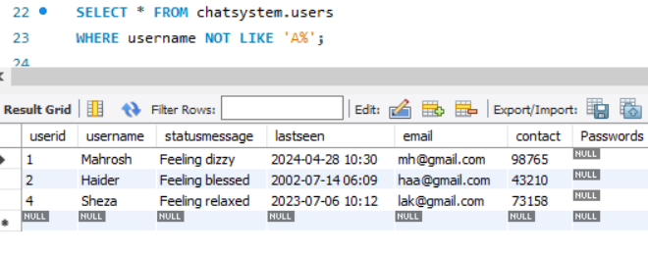

BETWEEN OPERATOR

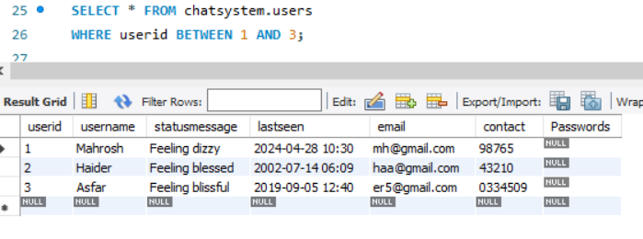

NOT BETWEEN OPERATOR
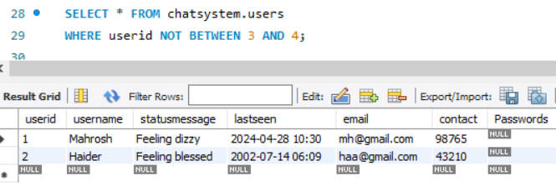

AND OPERATOR

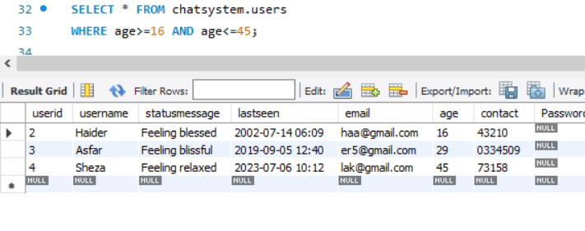

OR OPERATOR

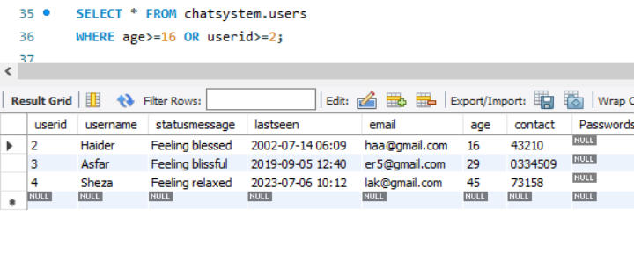

IN OPERATOR
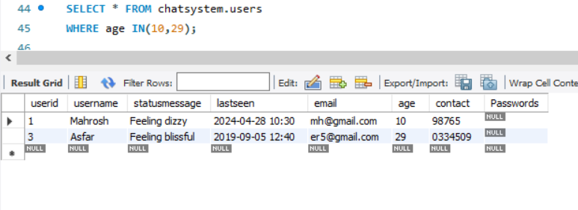

NOT IN OPERATOR

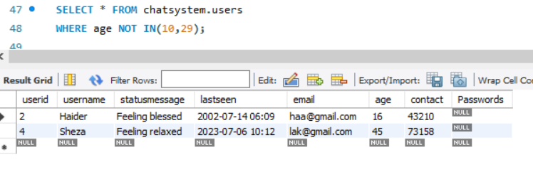

ORDER BY FUNCTION

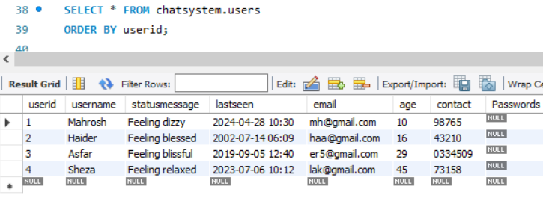

ORDER BY FUNCTION (DESC)
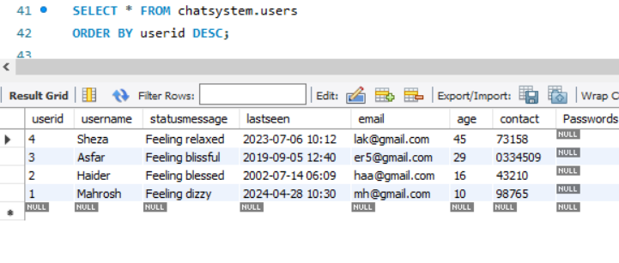

AGGREGATE FUNCTION
COUNT(*) Function
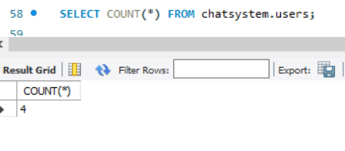

MIN Function
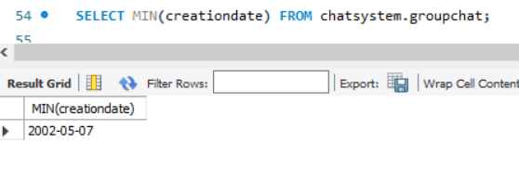

MAX Function
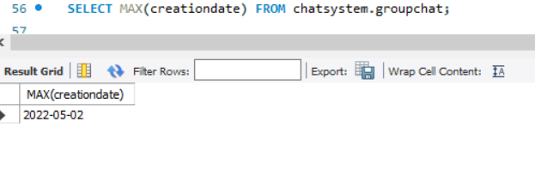

SUM Function

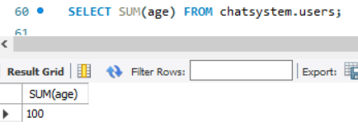

AVG Function
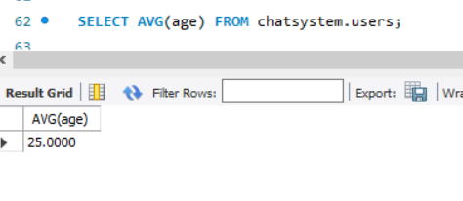

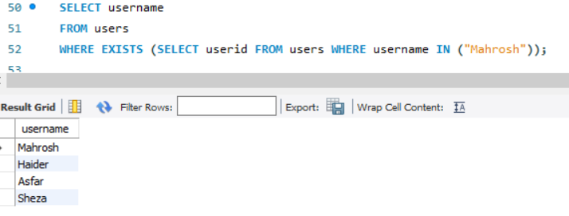
EXIST FUNCTION

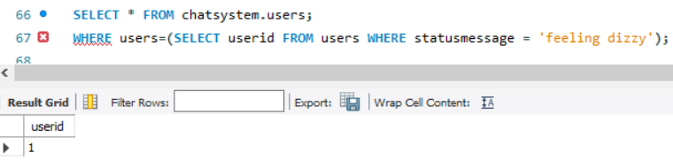
Sub-Queries

Form:
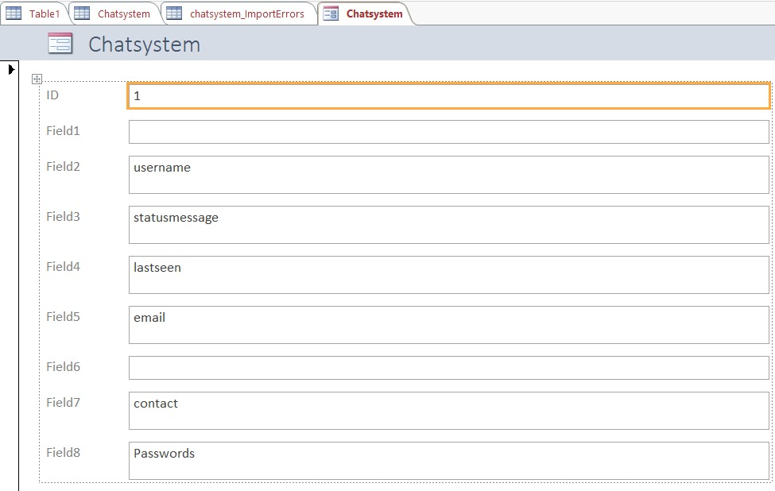

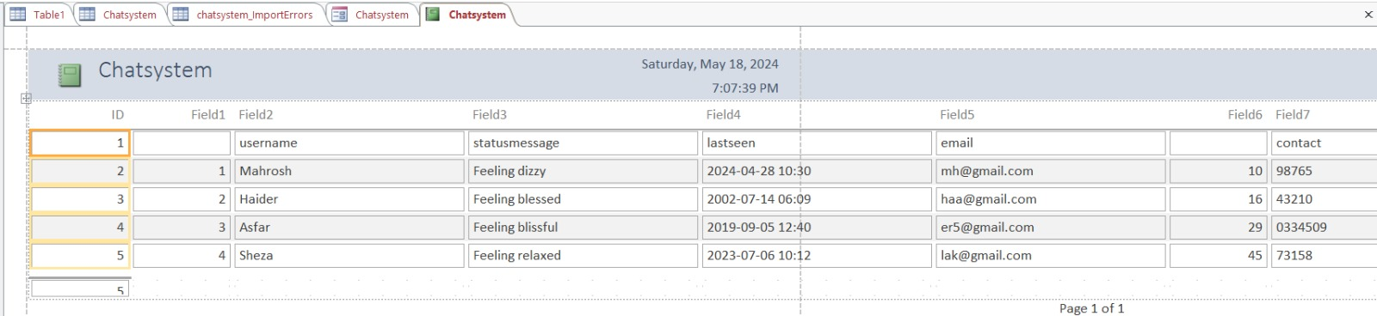
Report:

